5 Fashion Apps to Revamp Your Style
Gone are the days where you had nothing to wear, and you could do nothing about it. With the Internet at our fingertips, there are many fashion applications out there that aim to make “nothing to wear” as extinct as the dinosaurs. With fashion always changing, it’s gold to have options when you’re going for a new look or trying to hunt down a piece for your collection. Here are the top five apps to help you get out of a fashion rut.
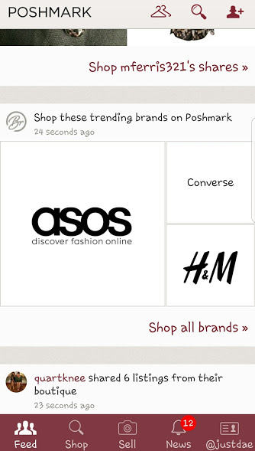

Poshmark
Ever since Macklemore’s song “Thrift Shop,” thrifting hasn’t been frowned upon. In fact, after that song, local thrift shops saw a spike in sales. Poshmark took thrifting and made it digital. List your clothes or shop other people’s closets and buy some pretty hot name brands for cheap. Some people even trade items in each other’s closets. Whether you’re a seller or a buyer, Poshmark is a great start.
iOS Download | Android Download
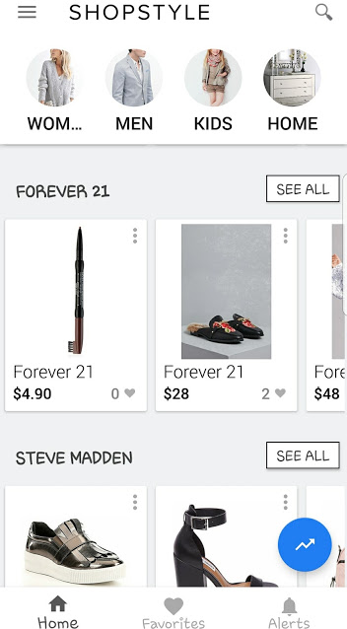

ShopStyle
One of the worst parts about shopping is knowing what you want, but not knowing where to get it. Here comes Shop Style to the rescue. Simply search what you’re looking for, and Shop Style will do all the shopping. It’ll show you varieties of what you’re looking for, where to buy it, and even alert you to a price drop. Shop Style has become the Google of fashion.
iOS Download | Android Download
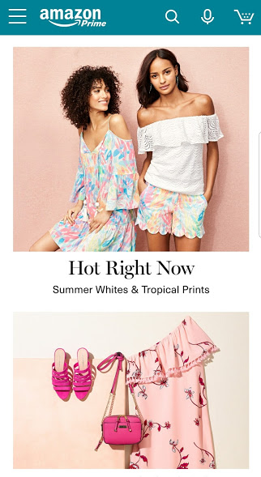

Amazon Fashion
Once upon a time, Amazon wasn’t known for fashion. In fact, people were hesitant to purchase clothes on Amazon. Then Amazon Prime happened, and the realization came that you could have a dress delivered in two days. With verified reviewers, Amazon has made it easy to find something that you’re looking for. Even shops like Make Me Chic and GoJane are getting into the Amazon game. As a consumer, what exactly do you have to lose with Amazon fashion?
iOS Download | Android Download
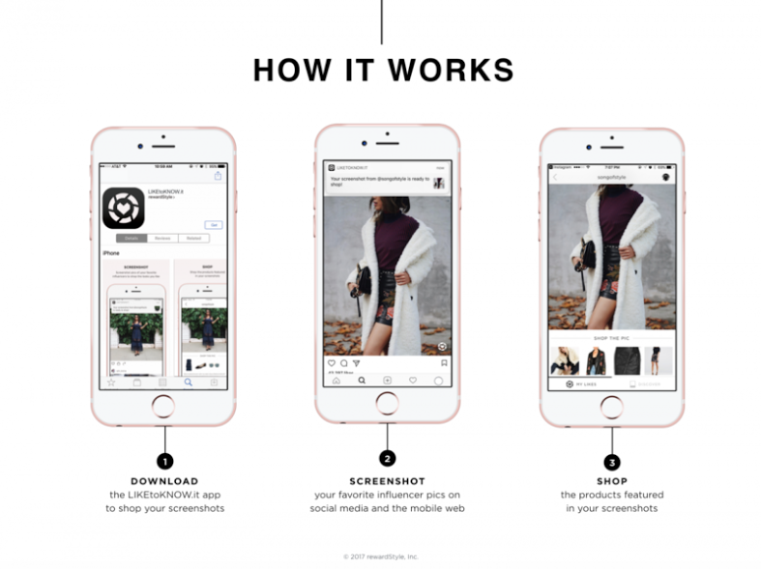

Like to Know It
Like to Know is more of an extension of Instagram than an actual app itself. What makes this Instagram extension so special is that by simply clicking on a Like to Know link in someone’s bio, you can shop their look directly from their Instagram. It’s hard not to include Like to Know on this list as fashion retailers and bloggers use it a lot.
iOS Download

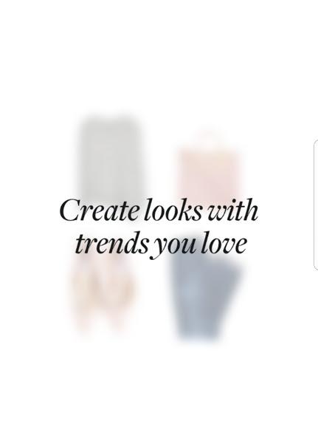

Polyvore
Polyvore is an old school app on the list. It’s not for shopping, but rather more of an inspiration app. Put together looks and share them with friends. Even shop the look after you put it together. It’s always good to have a starting point when you’re up for revamping your look.
iOS Download | Android Download
Whether you’re revamping your closet or wanting to look expensive without going overboard, there’s a fashion app out there to fall in love with. Of course, these aren’t all of the fashion apps, but only five of our favorites. What’s your go to fashion app? Leave it in the comments below so we can check them out. After all sharing is caring.

