5 Games to Enjoy Offline
Whether anyone wants to admit it or not, we’re all addicted to one game or another. There’s nothing worse than playing your favorite games and having to stop because there’s no internet. But not all games are data guzzlers. Some games are great offline too. Here are five of our favorite picks to feed your gaming addiction offline.
One: Two Dots

Two Dots is so simple it’s hard. Well, it starts out that way. Each level creates a different obstacle so that connecting the dots gets harder and harder. Some rounds you find yourself with lava in the way of your connection, or anchors trying to destroy your goal completely. You will eventually get frustrated and have to put the phone down, but it’s okay, because by that time you’re on level fifty and putting it down isn’t an option. The sad part is that you only get five free lives a day. Unless you’re paying for more, you’re going to have to put the game down.
Android | iOS
Two: Minecraft Pocket Edition
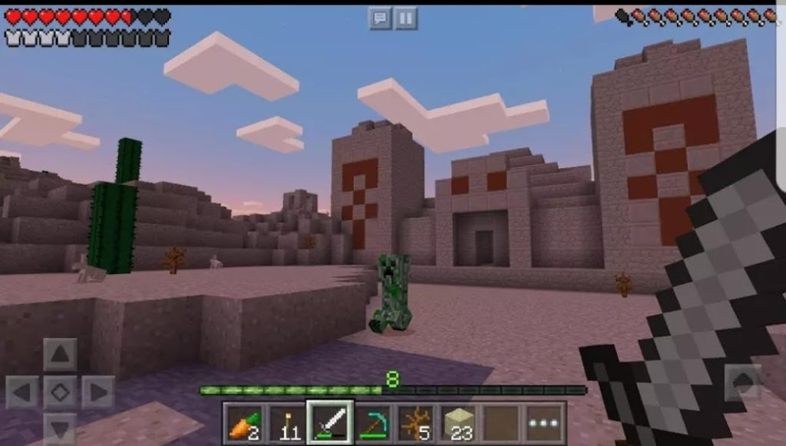
Minecraft may not have battles, trivia, or much of a challenge, but it’s fun and stimulating. Create worlds and get lost in building your own fantasy land. You can play offline and enjoy having the fun of Minecraft in your pocket. I’ve seen my nephews play and enjoy it, and even grown men love it. Between creating worlds offline and sharing them with your friends online, you’re prone to get addicted to Minecraft.
Android | iOS
Three: Subway Surfers

It’s hard to believe it’s been five years since Subway Surfers dropped, and it hasn’t surfed its way out of player’s hearts since. Help characters Fresh, Jake, and Tricky escape the cranky inspector and his dog by dodging incoming trains. It’s an endless game, and it might get a little routine, but you won’t be able to look away. A few times it stressed me out, but I loved every second.
Android | iOS
Four: Into the Dead
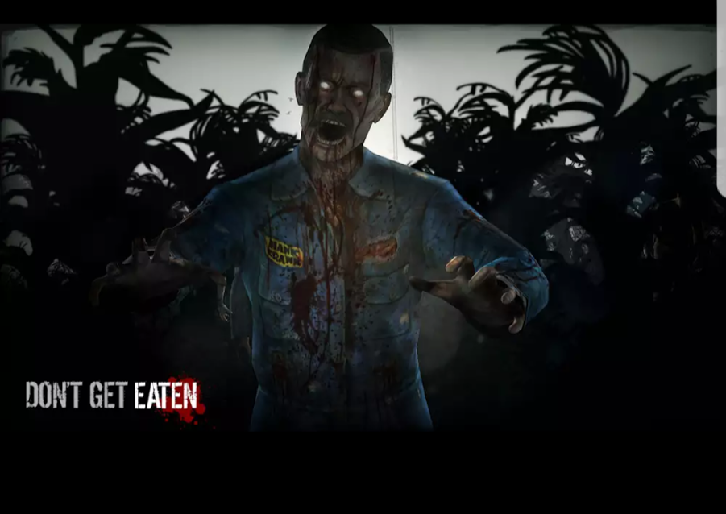
Run for your life in Into the Dead! A zombie apocalypse is happening and everyone is dead but you…for now. Maneuver around the city as fast as you can with the biggest mission being stay alive. The mini goals in between missions add a little flavor to the game, and it’s always updating so you never know what’s going to happen. You will always enjoy this adventure.
Android | iOS
Five: Crossy Road
This pixelated arcade looking game is cute, and it turns the true tale of why did the chicken cross the road into more of a please help this chicken cross the road kind of challenge. It’s pretty much an ever-changing, endless game of Frogger that will have you questioning why did you start and how do you stop playing? We didn’t love Frogger for its resolution though, we loved it because it was simple, and Crossy Road taps into that love. It’s been around for quite some time, and there’s no questioning why. It’s addicting! We warned you!
Android | iOS
Whether you’re building a Sim City or playing Pac Man, not having wifi or data is no longer a problem in the world of gaming. If you can think of it, there’s probably something for you to play when you’re not as connected as you want to be. There could only be five on this list, but we want to know, what’s your go to offline mobile game?

