5 Super Underrated S8 Features
This month marks two months since the Samsung Galaxy S8 release, though two months seems like eons in technology time. It’s been long enough that tech nerds are getting hyped about the Samsung Galaxy Note and the new iPhone set to drop. But let us not forget what a beauty the Samsung Galaxy S8 is. There are so many features on this piece of great technology that never get the attention they deserve. Here are my top five Samsung Galaxy S8 features that deserve a little more celebration.

One: Galaxy S8 Stickers
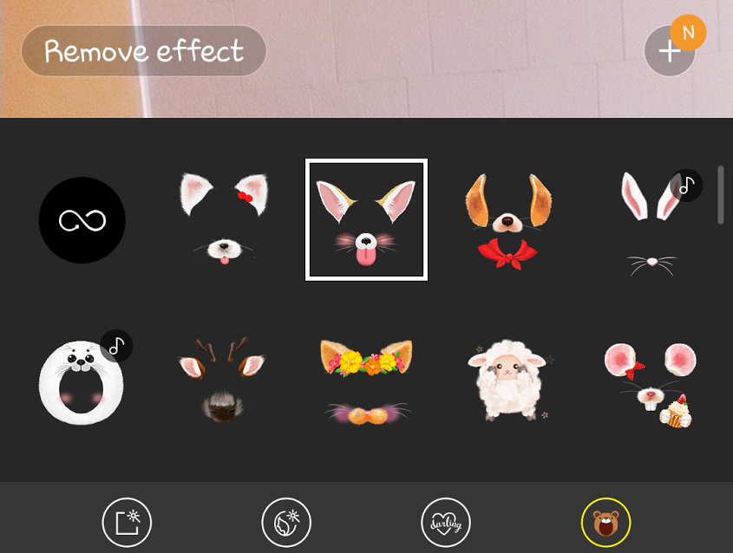
Snapchat has them, Instagram has them and now the Galaxy S8 has them. Before you even install any of these apps, the phone comes loaded with stickers that are great for procrastination. Wander into the camera application, and you can be anything from a bunny to a person eating Ramen. Because, why not?

Two: Floating Camera Button
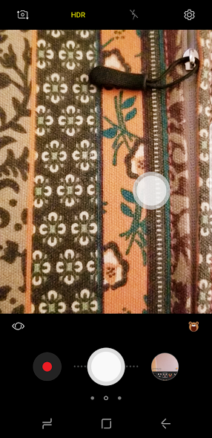
Also, in the camera app settings is the option to add another camera button and place it anywhere on the screen. This feature comes in handy when you’re not fond of where the actual camera button is, or when you need to take a selfie and don’t want to struggle with one-handed photography. I could see it being helpful for left-handed people too.

Three: Bixby

Peeps are either “yay” or “meh” about Bixby right now, but this AI has potential to be great. Even though it’s having hiccups with voice commands, Bixby has the power to be bigger than Siri. Right now, it can do some pretty awesome things like shop for anything that you take a picture of. Simply take a photo of what you’re looking for, and Bixby will find it on Amazon and show you the price. No more struggling to find where your friend got her cute new shoes from. Just take a photo of them.

Four: Bluetooth 5.0
The Galaxy S8 is the first mobile device to have Bluetooth 5.0. This allows the phone to have a longer range to whatever it’s connected to, and you can even connect to two devices at the same time. Imagine the partying that could happen and how impressed your friends will be! You don’t just go to parties, you are the party!

Five: File Management
This one may sound boring, but if you’re a photo hoarder and you’re worried about running out of space (good luck with that because there’s expandable storage), the S8 is here to save the day. Click into your file settings, and you’ll find this File Management setting that detects files you haven’t used in a while, unnecessary files, and even duplicate files. It’s almost as if the people at Samsung saw a problem and fixed it before we all complained about it.
There’s much more to explore on The Galaxy S8, and two months is a short period of time to spend with a phone such as this. One might even call this a tiny computer in your pocket. There are so many things to love about this phone, but we only picked five. What’s your favorite Samsung Galaxy S8 feature that doesn’t get enough love? Leave it in the comments below.

