iOS 11’s Most Buzzed About Features
A new iOS update is coming sooner rather than later. Even if you don’t rush to get the new iPhone, the features make it feel like you have one. iOS 11 features will either make you giddy or frustrate you, but no matter where you stand on the matter, they are coming. Here are some of the iOS 11 standout features from the Apple Event.
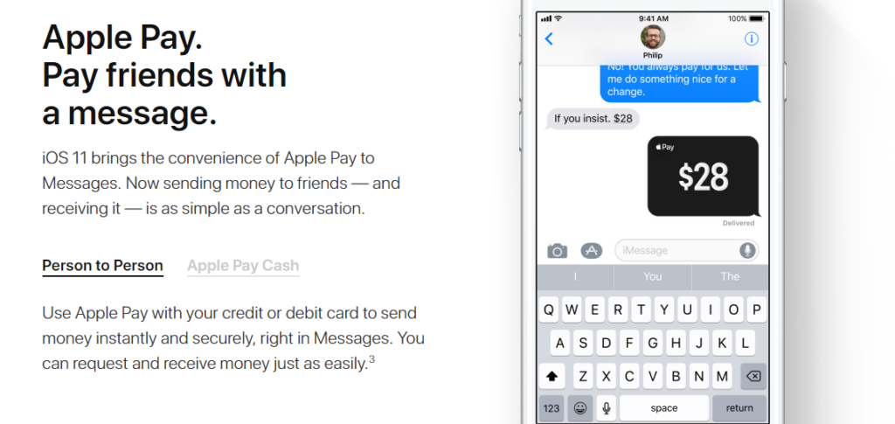

Revamped Messages App
Titles are bolder, and the typography is even a little different. Besides the huge Messages display at the top of the app, not much seems different at first. Don’t be fooled though. This Messages App is definitely a standout. Message will allow you to do more without leaving the application. One surprise is that you can use Apple Pay to pay friends without leaving the Messages App. You can also share Apple Music songs and Starbucks gift cards with friends and family via Messages.
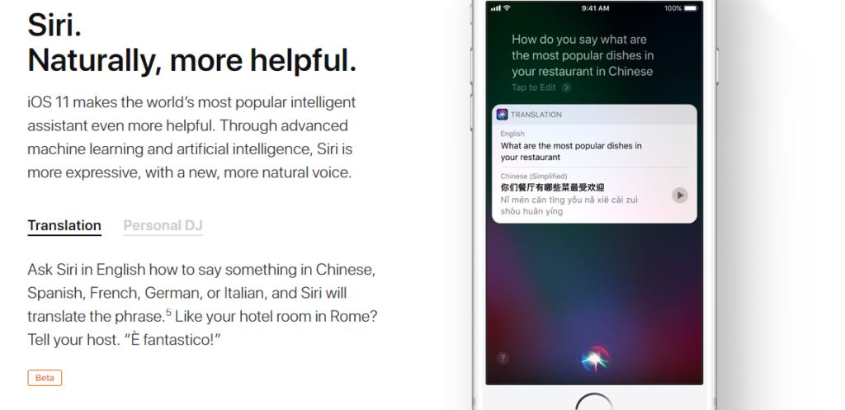

Chat with Siri
Before iOS 11, Apple users spent a great deal of time talking to Siri, but now you have the option to chat with her. Go to General, accessibility, Siri, and toggle on the Type to Siri option. You get to find your answers to your most curious questions at the tap of a button. It’s good to have options.

Screen Recording
Maybe you want to show off to your friends about the newest features on iOS 11, or maybe you want to slyly take a screenshot of your friends’ Snapchat. I’m not judging you! But Apple has made it easier to record your screen. Simply go into your Control Center and tap on Screen Recording, and you’ll be instantly recording your screen.

One Handed Keyboard
Anyone with an iPhone 6 or higher can turn their usual keyboard into a one-handed one, making it accessible and easier to use. Hold the globe key on your keyboard to dock it to the left or the right screen. Like magic, you can now use your keyboard with just one hand. It is all about the little things in life, right?
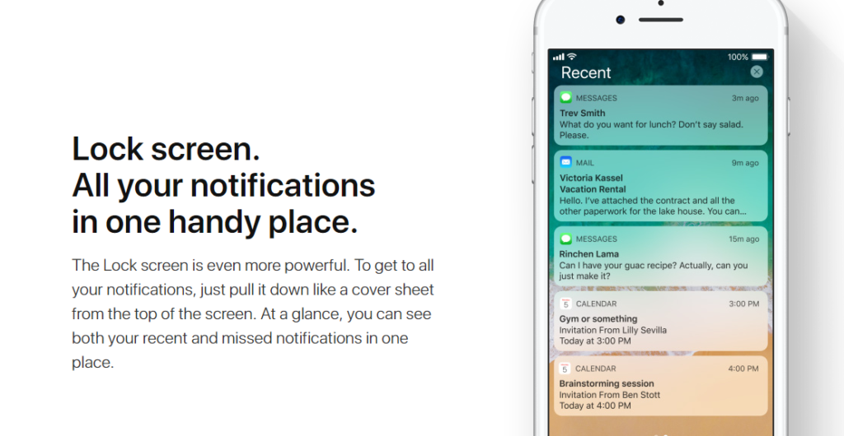

Revamped Locked Screen
iOS 11 seems to have a few major redesigns, but they’re all so subtle. Simply swipe up to unlock your device in iOS 11. The notification center is also more connected in the lock screen. Instead of swiping down from the top of the screen, swipe up to get all your notifications.
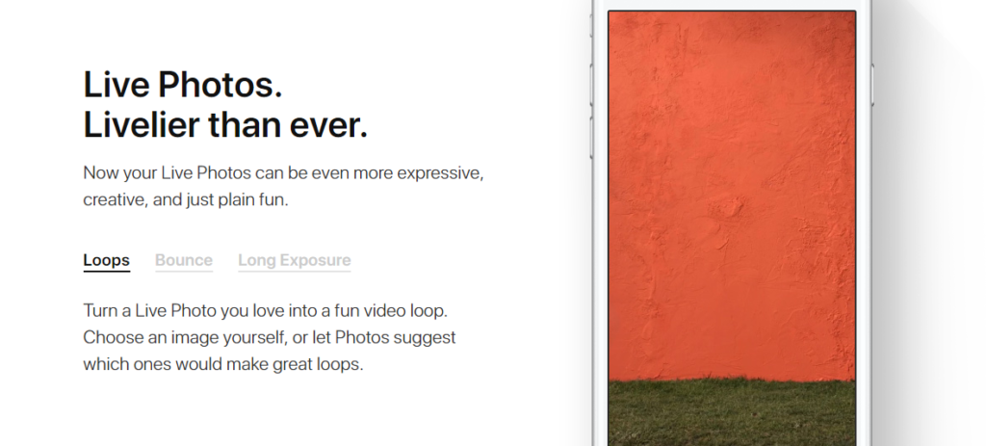

iOS Camera App Update
When users thought it was impossible for their iPhone Camera to do more, iOS 11 has one-upped everyone. The new update allows users to add loop and bounce effects to live photos. Apple is also introducing HEIF (High Efficiency Image File Format) to keep your pictures stored pristine, and now they take up less space.
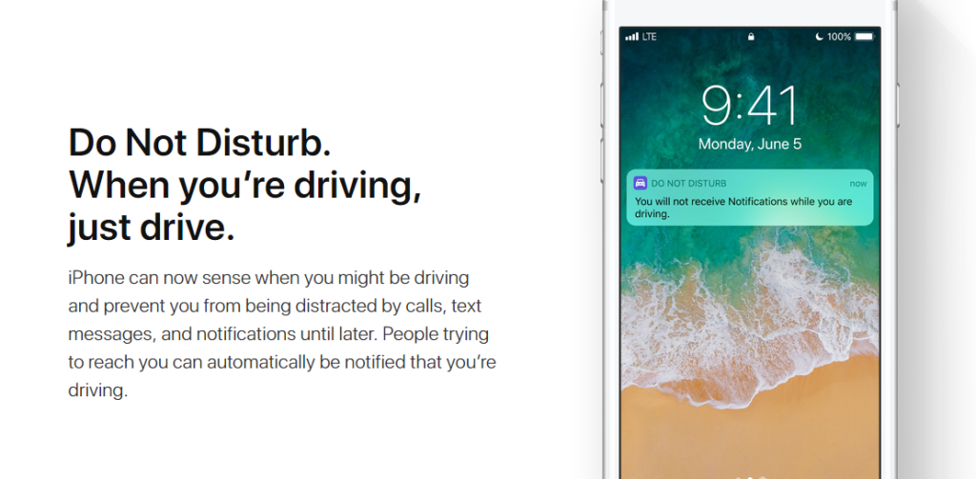

Do Not Disturb While Driving
Forget texting and driving, or even being bothered while you’re on the road. Your phone will not be a distraction, since this Do Not Disturb While Driving feature silences everything and everyone. You can customize it to your liking, but for the most part it’s peace of mind. Senders can type the word urgent when something really needs your attention, but what could be more important than your life? We’ll wait.
It would take a while to go through every new feature in iOS 11, so these are just some of the highlights. At this point, any change is a big change because people have iPhones for the simplicity of its iOS. What do you wish Apple would change about iOS? Leave it in the comments below.

