Microsoft Teases Xbox One: X at E3
Chardaé 2 months ago NEWS / E3, GAMING, MICROSOFT, XBOX ONE X

E3, or the Electronic Entertainment Expo happened, and as usual there were a lot of awesome gaming announcements. But everyone had their eyes on Microsoft, as they haven’t had a game system drop since the release of Xbox One in 2013. Usually people are either Team Sony or Team Microsoft, but both teams were all ears to see what Microsoft had been working on since its last console. Depending on who you ask, the new Xbox One: X was either really cool or WiiU underwhelming.
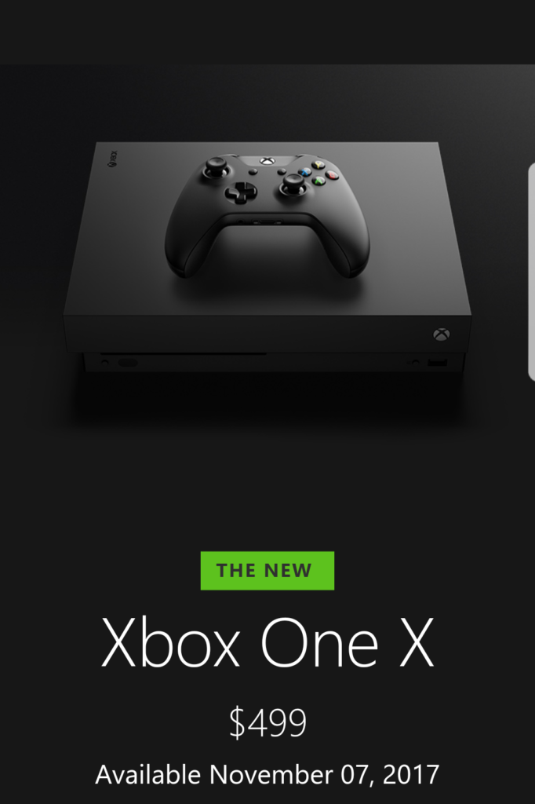
After months of speculation, Xbox One: X has been formally welcomed to the Microsoft family, and there are quite a few interesting things about it. Here are the top four announcements on the Xbox One: X.

Faster Specs
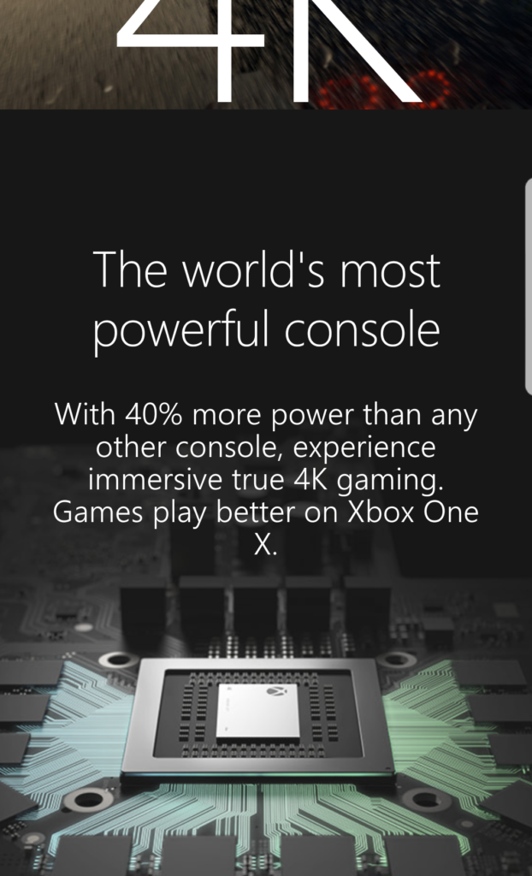
After getting over the name and questioning why Microsoft didn’t opt for Xbox 2, I listened closer during the announcement and heard that this thing is powerful. Xbox One: X joins a family of powerful consoles, and just when we think we’ve reached peak technology, Microsoft surprises fans. Xbox One: X has 4k gaming (when played on a 4k monitor), faster load times and smoother frame rates. It’s said to be the smallest Xbox, yet has forty percent more power. It’ll be amazing to see what’s next after this thing drops.

New Games
With a new console comes new games, and Microsoft announced 42 games for their Xbox One: X. It seems like they’re making sure that they cover all their bases. There’s a game for everyone from RPG to action. Twenty two of the announced games are Microsoft exclusives, and their following alone should have people rushing to get a new Xbox. Life is Strange: Before the Storm, Dragon Ball Fighter Z, Assassin’s Creed: Orgins, and Black Desert are a few games to get excited about.

Xbox One Backwards Compatibility
I could have included this in specs, but this isn’t just one small feature, and it deserves its own highlight. Not being able to play your old Xbox games on your new console can be a deal breaker, especially if you’re attached to your collection. Fans let out a sigh of relief that with Xbox One: X, their old games were compatible, and they wouldn’t have to go out and repurchase them. Folks at Microsoft even took it a step further by announcing that not only are the older games compatible, but also the accessories.

Surprising Price
Your level of productivity might go down in November when the Xbox One: X drops, but the price can’t possibly get any lower. At a retail price of $499 for the Xbox One: X and $249 for Xbox One: S (a smaller sleeker Xbox), it’s a steal. As far as new consoles go, this may be a strong contender to compete against Sony’s Playstation 4.
No matter if you’re Team PC, Microsoft or Sony, there’s no doubting that the Microsoft Xbox One: X looks nice. The question is, will it be nice enough? If you’re already an avid Xbox fan, it’ll keep you fascinated. Will you be purchasing the new Xbox? What was your favorite E3 Announcement?

