RollerCoaster Tycoon 4 Mobile (Review)
It’s no surprise that Atari is responsible for the ever so popular RollerCoaster Tycoon 4 Mobile Game. It screams nostalgia from the music to the roller coasters. As soon as I started the game, I was brought back to when I was a kid playing the PC version of RollerCoaster Tycoon. It feels great to now have it in my pocket. Of course, RollerCoaster Tycoon 4 is a little more challenging. Everything you do and build requires coins and tickets, and I will not deny purchasing a few.
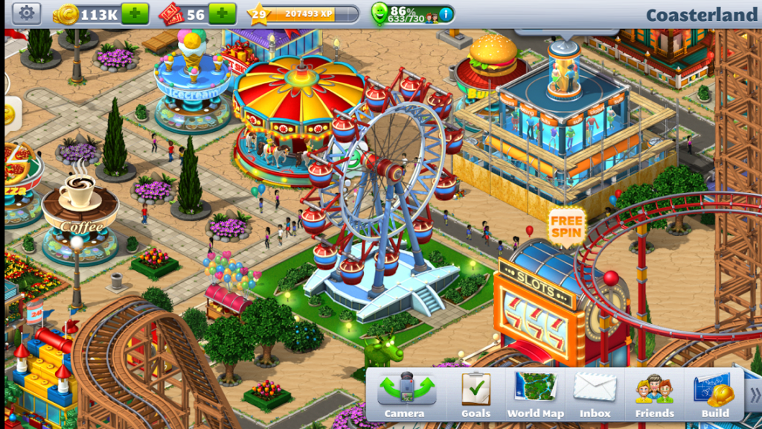
Just when I was getting bored and thought I could put the game down, I was surprised to find out that I unlocked a different kind of coaster. And just when I got comfortable with the coasters, I discovered a random gift for me in the parking lot. The point is that there will always be something to do in RollerCoaster Tycoon 4. If somehow you get bored of of your park, you can visit others and even start an empire.
Each level has goals, and the completion of these goals helps you earn coins and tickets to create, update, and conquer your park. You get to run your park down to the last trashcan (and you will need them as park goers are not the cleanliest of people).
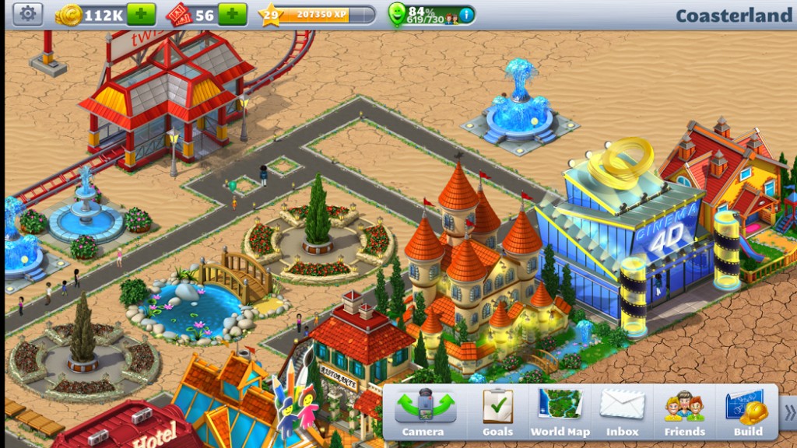
My top three favorite things about RollerCoaster Tycoon are building roller-coasters from scratch, mini games within the game, and last but not least the impeccable graphics.
Customizing your own roller coasters track by track is not only an adventure within itself, but it also costs less coins. It’s important to note that, although pretty, the already completed coasters are not as rewarding when it comes to return on investment.
Also, a lot of people don’t know about the mini games within Roller Coaster Tycoon 4. They’re simple, but they’re very helpful when you’re low on coins or tickets. Inserting a Wheel of Fortune, Food Rush, and Slot Machine in your park are all great investments and useful opportunities to earn free coins every day.
My favorite mini game is Food Rush, because it reminds me of the game Burger Rush. It involves filling the most burger orders in ninety seconds. The more correct orders you fill, the more coins you get! This is important especially when you’re a few coins from leveling up. When you get the chance, add Burger Rush to your park immediately.
Last but not least, I enjoy the graphics. Something so simple as graphics can make or break a game. This mobile game is not the PC version of this game as the quality of attractions is awesome. There’s very little lag and the colors are bright. I remember as a kid being in love with the graphics on the PC version, but it’s only because I didn’t know any better at the time.
If I had one complaint about the game, it would be that sometimes the goals are confusing, and I have to google a few explanations of them. I’m not going to complain much though, because it was also a pro. If it wasn’t for that hiccup, I wouldn’t have found that the redemption code “wheee” gives you a free roller coaster. (You’re welcome – I just hope you have enough land for it!) I also wish the game had a camera view of riding the roller coasters, but I know that kind of thing would take up way too much space on my phone.
Does this game never end? Yes! Does it live up to the hype from my childhood? It most definitely does. This game will have you checking your phone every day to collect coins and build new rides. You might even find yourself spending money on coins and reliving your childhood just a little bit too much. Don’t believe me? Check it out for yourself and download it on Android here and iOS here.

Save

