Taylor Swift Presses Play on Streaming Services
Chardaé 2 months
In an unexpected move this month, Taylor Swift got back together with streaming sites. Three years ago, the pop singer pulled her entire catalog from Spotify and other free streaming apps. According to the CNN article “Taylor Swift to Spotify: You Belong with Me” by Lisa France, Swift argued that music shouldn’t be free and that she wanted zero parts in this music streaming experiment. Swift even went as far as telling Spotify that they didn’t pay artists enough, and ads in between songs weren’t enough for it to be considered a paid platform. Apparently, Swift wasn’t feeling the free part of Spotify’s business model.
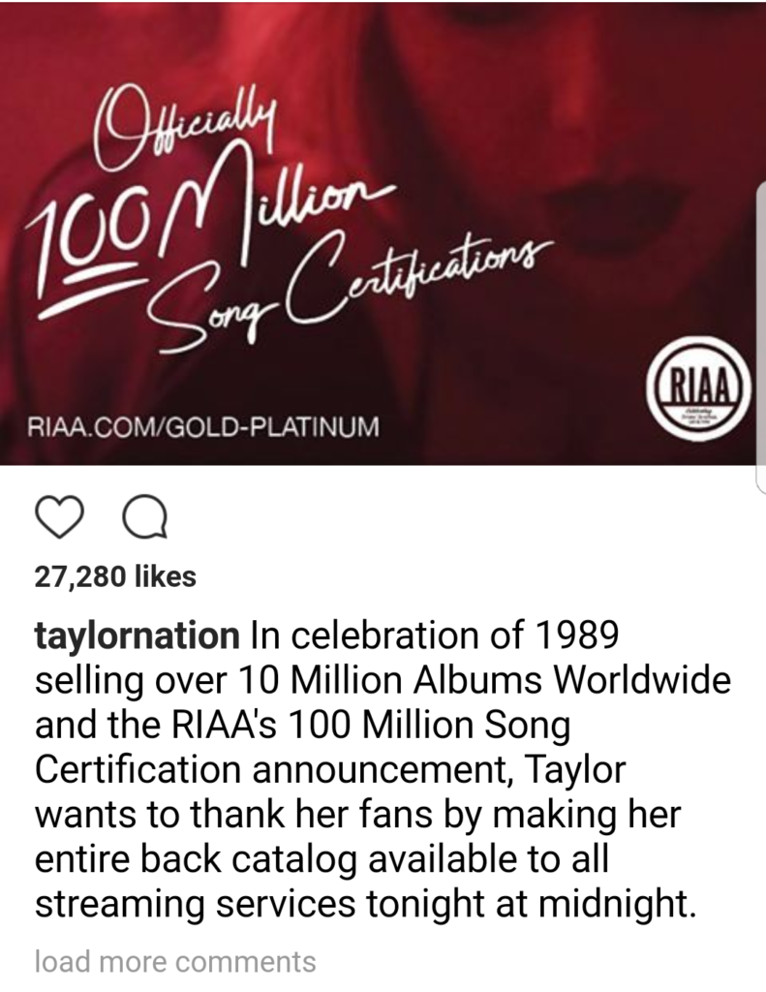
The music streaming experiment, as she called it, is still around, and three years later Spotify has one of the largest streaming audiences worldwide. Either she realized that streaming is the new record store, or she just doesn’t care anymore. Swift quietly returned to Spotify, Tidal, Amazon Streaming, and other streaming music applications. The singer posted the announcement on Instagram boasting that her hit album 1989 sold over 10 million albums worldwide, and in celebration, her back catalog was returning to streaming services everywhere (McCormick).
Although this was the official reason, people are questioning if she wanted to steal the thunder from rival Katy Perry’s recent release, as the two have been notoriously feuding since their “Bad Blood.” Whatever the reason, Swifties are rejoicing and shaking it off until further notice.
With streaming more popular than buying and downloading, it’s interesting to see where the future of the music industry goes. Will streaming be the thing forever? If so, musicians are going to have to rely on other means to make their bread and butter. For example, right now musicians make more money from touring and merchandise than their music sales, because people simply aren’t buying music like they used to.
Back in March, in an article on the Verge, Rich McCormick reported that Spotify was mulling over offering paid subscribers new music before the free subscribers. This move would cater to artists like Swift who don’t want their life’s work handed out like free candy on Halloween night. However, this proposal would also mess up Spotify’s freedom that lets listeners choose how to consume their music. Even if listeners are listening for free, they are contributing to ad revenue, which is better than what was happening in the Napster and Limewire days, when people were just stealing music. Some would think that some money is better than no money at all.
Until musicians and streaming services can agree on the value of music, the climate of the music industry will be a bit cloudy. But at least listeners can leave it to the business people to figure it out and just enjoy the music. After all, isn’t that what it’s all about? With no listeners, musicians like Taylor Swift wouldn’t have a company to argue with about said revenue.
Do you use a free service like Spotify and Pandora? Do you think the climate of the industry is a bit ridiculous, or is it getting better? Share your views on the free streaming argument in the comments section below.
Citation:
France, Lisa. “Taylor Swift to Spotify: You Belong with Me.” CNN,www.money.cnn.com/2017/06/09/media/taylor-swift-streaming-spotify-tidal-amazon/index.html. Accessed 13 June 2017
McCormick, Rich. “Taylor Swift is putting her albums back on all streaming services.” The Verge, https://www.theverge.com/2017/6/8/15766490/taylor-swift-albums-spotify-1989. Accessed 13 June 2017

