T-Mobile and Sprint Talk Merger
Chardaé 2 months ago NEWS / MERGER, NEWS, SPRINT, T-MOBILE
It seems like every other year T-Mobile and Sprint stop competing for a millisecond to consider becoming BFFs. The two cellular companies are thinking about it again, and just like every other year, it’s complicated. But this year, a merger is not completely absurd.
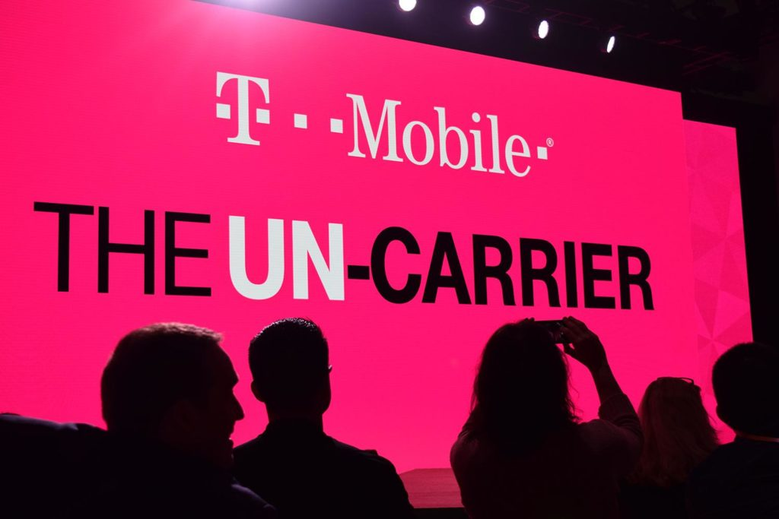
Back in 2014, Sprint’s parent company SoftBank wanted to buy T-Mobile. US regulators quickly popped up and ended talks with the budding BFFs after expressing consumer and industry concerns. As soon as the Obama administration was out, the two companies began talking again. Now that Trump is president and the sky’s apparently the limit, they’re back at the table. The merger just keeps popping up in the conversation, and if there’s a will, there’s a way.
According to an article by Reinhardt Krause published on Investor’s Business Daily, this time around, T-Mobile is stronger as they’ve taken over a big population of the market since 2015 (Krause). T-Mobile’s sudden strong hold on the Market has lots to do with T-Mobile CEO John Legere’s “Uncarrier” movement and the rebranding of T-Mobile as a whole since the last merger conversation. Sprint has tried mergers in the past, but their Nextel merger didn’t really help them back in 2005 (Krause). Since then, they’ve been struggling to find their audience, but not even Verizon’s ex-spokesman Paul Marcarelli can rescue Sprint when it comes to expanding their customer base.

This is all great news for T-Mobile, but both parent companies have loads of debt, and it’s a tossup on whether US regulators will give the green light for such a big merger. Then again, this is the Trump Era and anything can happen.
Of course, in today’s political climate no one is certain about the future, but in general a merger of this magnitude would be utter bad news for consumers. Having less choices means prices go up, and no one wants to pay more than they’re already paying. If given the green light by the US government, the merger wouldn’t happen right away. It would take three to five years to be totally integrated, and that’s a lot of time to figure things out (Krause). Such a timeline would be a complete win for their competitors (Verizon and AT&T) to prepare for such a mega move. In tech time, three years is eons as the climate can change from day to day.
The fact that these two companies keep coming to the table means that this merger isn’t far off. It may not happen right now, but eventually they’ll get it together literally and figuratively. Having one less option would be hurtful to consumers, but a win for both companies as they’ve been exploring the idea of being BFFs for years. The Trump administration might just be the people to help make their dreams come true. Do you think a merger of this magnitude could help one company more than the other? Would you support T-Mobile and Sprint possibly becoming one company?
Citation
Reinhardt, Krause. “T-Mobile, Sprint Merger Integration Could Take Five Years.” Investors Business Daily, www.money.cnn.com/2017/06/09/media/taylor-swift-streaming-spotify-tidal-amazon/index.html. Accessed 21 June 2017

