T-Mobile Tuesdays Celebrates One Year
When T-Mobile’s CEO John Legere announced T-Mobile Tuesdays, the industry thought he was crazy. Disruption has always been his thing, and this by far seemed to be crazier than both his un-carrier plan and his newest plan to make phone numbers truly mobile. Legere announced the T-Mobile initiative to reward loyal customers and entice new ones around a year ago. With over two million customers, T-Mobile is one of the largest carriers in the United States. With stunts like this, we now see why they’re ranked number 3.
T-Mobile Tuesdays celebrated its one year anniversary this month and shows no signs of stopping anytime soon. What is T-Mobile Tuesdays you ask? It’s where every Tuesday, T-Mobile customers are showered with a few gifts and even a chance to win a grand prize of the week. In the past year, T-Mobile has given away free pizzas, books, T-Mobile merchandise, a trip to an awards show, free movie tickets, and T-Mobile stock. Each week has a special theme with a different sponsor. Past sponsors have included Dominos, Papa Johns, and Pet Smart.
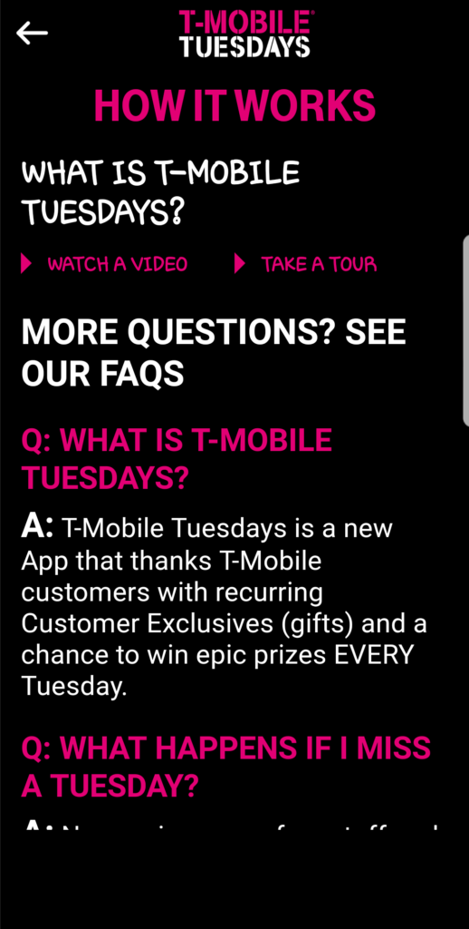
Why is T-Mobile doing this? In short, the answer is because they can. Rewarding customers for simply existing is a pretty impressive loyalty program. In other words, they’re laughing at other carriers like, “what are you giving your customers?” Not only is the customer winning here, but T-Mobile has also created this pipeline where they’re directly introducing brands to potential new customers every week.
Dominos Pizza was one of the first re-occurring rewards with a free medium pizza special. Although the special was carry-out only, they couldn’t keep up with the pizza demand and had to bow out gracefully. Imagine the amount of people who wouldn’t have gotten Domino’s if it wasn’t for this particular weekly special. Now, also imagine what that kind of power could do for an upcoming company.
How does a T-Mobile customer go about getting thanked on T-Mobile Tuesday? Download the T-Mobile Tuesdays app in the app store and patiently wait for Tuesday to arrive. On Tuesday, enter your phone number (confirming you’re an actual T-Mobile customer) and enjoy the perks of rocking with Team Magenta. Customers never know what they’re going to get until the day of. Sometimes the gifts are great, and sometimes we’re all “it’s free.” Almost every week customers are guaranteed a movie rental, and every week customers enjoy it.
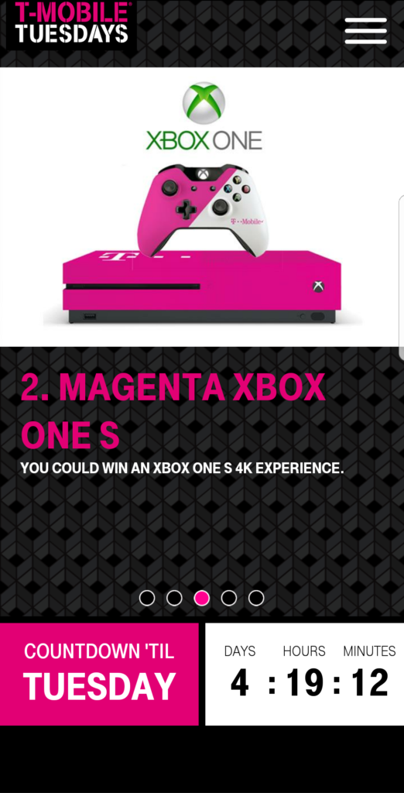
Some of my favorite T-Mobile freebies were the free Suicide Squad tickets, free Baskin Robbin’s ice cream, and the free movie rentals. My mom has also gotten in on this program, and she’s still enjoying a free magazine subscription. I’m still holding on to my free T-Mobile stock.
How long will this season of thanking last? No one really knows, but judging by Legere’s Twitter feed, the thanking won’t stop anytime soon. For more on T-Mobile Tuesdays check out the official Get Thanked Website. Don’t be afraid to download the app, because apparently everyone is a winner. Are you a fan of T-Mobile? Have you gotten thanked this year?

